附件5
铁岗－石岩水库饮用水水源保护区示意图及拐点坐标
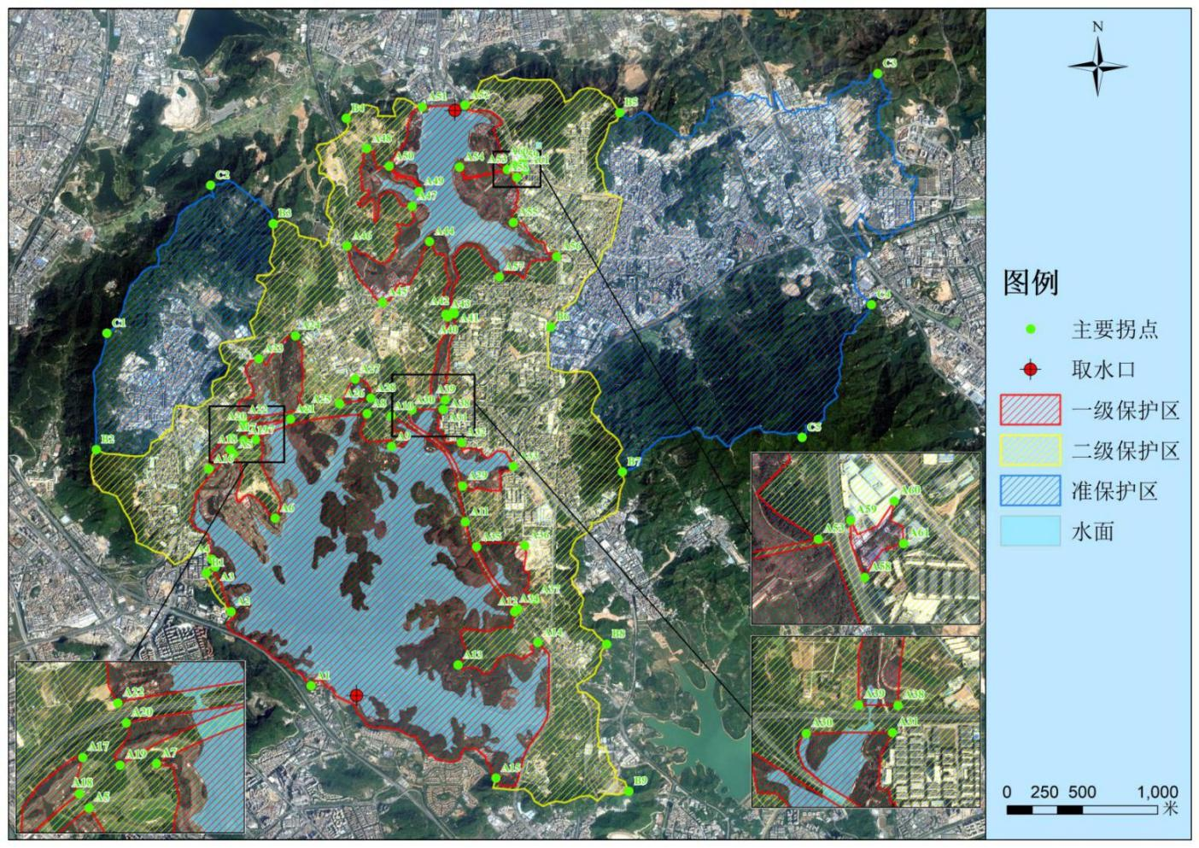
铁岗－石岩水库饮用水水源保护区示意图

铁岗水库－石岩水库饮用水水源保护区主要拐点坐标
拐点 | 经度 | 纬度 | 拐点 | 经度 | 纬度
A1 | E113.881431° | N22.612841° | A39 | E113.901128° | N22.659894°
A2 | E113.868271° | N22.625021° | A40 | E113.903940° | N22.673499°
A3 | E113.865678° | N22.632396° | A41 | E113.904982° | N22.674031°
A4 | E113.865148° | N22.633635° | A42 | E113.904809° | N22.674406°
A5 | E113.868665° | N22.650901° | A43 | E113.903551° | N22.673927°
A6 | E113.875529° | N22.640387° | A44 | E113.900905° | N22.685874°
A7 | E113.872287° | N22.653285° | A45 | E113.893148° | N22.675886°
A8 | E113.890670° | N22.657587° | A46 | E113.887351° | N22.685131°
A9 | E113.894678° | N22.652175° | A47 | E113.898027° | N22.691680°
A10 | E113.894624° | N22.657182° | A48 | E113.890584° | N22.701166°
A11 | E113.906798° | N22.639790° | A49 | E113.899175° | N22.694103°
A12 | E113.914890° | N22.625021° | A50 | E113.894275° | N22.698265°
A13 | E113.905590° | N22.616253° | A51 | E113.899730° | N22.708019°
A14 | E113.918699° | N22.619948° | A52 | E113.906756° | N22.708311°
A15 | E113.911831° | N22.597656° | A53 | E113.913691° | N22.697734°
A16 | E113.864614° | N22.648477° | A54 | E113.905831° | N22.698112°
A17 | E113.868315° | N22.653622° | A55 | E113.914679° | N22.689030°
A18 | E113.868130° | N22.651663° | A56 | E113.921807° | N22.683417°
A19 | E113.870343° | N22.653204° | A57 | E113.912381° | N22.680084°
A20 | E113.870665° | N22.655470° | A58 | E113.915270° | N22.696431°
A21 | E113.878044° | N22.656677° | A59 | E113.914795° | N22.698369°
A22 | E113.870205° | N22.656548° | A60 | E113.916269° | N22.699024°
A23 | E113.872849° | N22.666608° | A61 | E113.916584° | N22.697582°
A24 | E113.878867° | N22.670386° | B1 | E113.864194° | N22.631405°
A25 | E113.880661° | N22.658321° | B2 | E113.846100° | N22.651673°
A26 | E113.886134° | N22.659210° | B3 | E113.875208° | N22.688836°
A27 | E113.888677° | N22.663258° | B4 | E113.887189° | N22.706132°
A28 | E113.891257° | N22.660142° | B5 | E113.932164° | N22.707077°
A29 | E113.906367° | N22.645665° | B6 | E113.920862° | N22.671818°
A30 | E113.898021° | N22.658192° | B7 | E113.932627° | N22.648000°
A31 | E113.903140° | N22.658249° | B8 | E113.930048° | N22.619698°
A32 | E113.906147° | N22.652831° | B9 | E113.933685° | N22.595480°
A33 | E113.914698° | N22.648903° | C1 | E113.847849° | N22.670804°
A34 | E113.915437° | N22.625515° | C2 | E113.864896° | N22.695122°
A35 | E113.908643° | N22.635682° | C3 | E113.974594° | N22.713496°
A36 | E113.916550° | N22.635910° | C4 | E113.973587° | N22.675493°
A37 | E113.918292° | N22.627019° | C5 | E113.962189° | N22.653680°
A38 | E113.903477° | N22.659868°
其中，拐点A1-A2-A3-A4-A5-A6-A7-A8-A9-A10-A11-A12-A13-A14-A15、A16-A17-A18、A19-A20-A21、A22-A23-A24-A25、A26-A27-A28、A29-A30-A31-A32-A33、A34-A35-A36-A37、A38-A39-A40-A41、A42-A43-A44-A45-A46-A47-A48-A49-A50-A51-A52-A53-A54-A55-A56-A57、A58-A59-A60-A61所包络的区域为一级保护区，B1-A3-A4-B2-B3-B4-A51-A52-B5-B6-B7-B8-B9-A15与一级保护区之间所包络的区域为二级保护区，B2-C1-C2-B3、B5-C3-C4-C5-B7与二级保护区之间所包络的区域为准保护区。

