附件
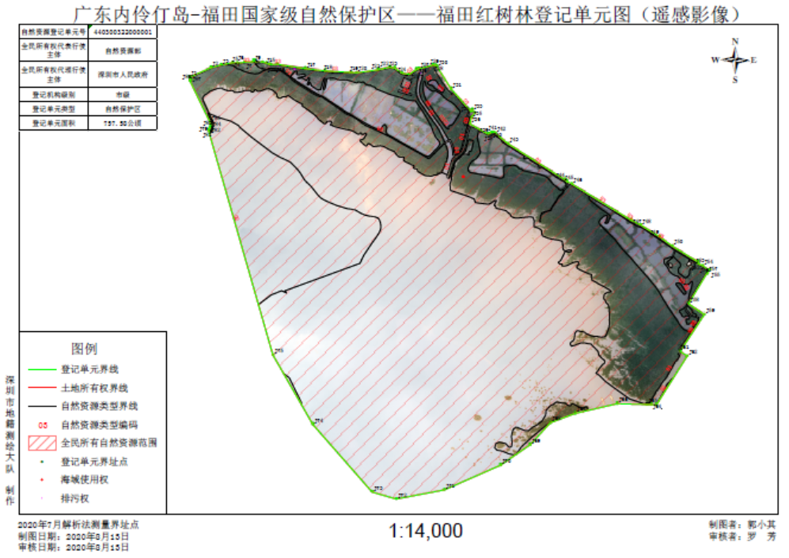
福田红树林自然资源登记单元坐标表

界址点号 | X坐标 | Y坐标
J1 | 2492348.34 | 499690.90
J2 | 2492421.07 | 499846.60
J3 | 2492442.97 | 499921.54
J4 | 2492461.35 | 500005.90
J5 | 2492458.92 | 500040.47
J6 | 2492464.88 | 500094.85
J7 | 2492466.69 | 500094.78
J8 | 2492469.86 | 500154.57
J9 | 2492473.98 | 500157.09
J10 | 2492474.22 | 500169.99
J11 | 2492470.42 | 500172.31
J12 | 2492468.41 | 500224.68
J13 | 2492462.91 | 500253.43
J14 | 2492453.13 | 500276.29
J15 | 2492450.99 | 500286.27
J16 | 2492454.57 | 500332.90
J17 | 2492426.67 | 500539.23
J18 | 2492411.93 | 500686.80
J19 | 2492404.08 | 500876.30
J20 | 2492401.99 | 500916.51
J21 | 2492426.81 | 501074.40
J22 | 2492447.63 | 501161.21
J23 | 2492441.57 | 501197.01
J24 | 2492405.41 | 501249.54
J25 | 2492396.64 | 501302.20
J26 | 2492434.02 | 501355.73
J27 | 2492438.01 | 501373.42
J28 | 2492469.13 | 501476.47
J29 | 2492466.63 | 501496.45
J30 | 2492457.85 | 501507.44
J31 | 2492296.27 | 501612.42
J32 | 2492133.93 | 501761.92
J33 | 2492142.93 | 501770.78
J34 | 2492122.57 | 501790.42
J35 | 2492089.63 | 501766.04
J36 | 2492040.61 | 501755.31
J37 | 2491970.33 | 501886.48
J38 | 2491968.78 | 501893.51
J39 | 2491971.21 | 501899.76
J40 | 2491981.23 | 501914.40
J41 | 2491983.14 | 501929.54
J42 | 2491976.91 | 501943.37
J43 | 2491900.27 | 502037.84
J44 | 2491641.79 | 502460.83
J45 | 2491629.22 | 502473.45
J46 | 2491613.30 | 502510.66
J47 | 2491353.47 | 502951.62
J48 | 2491319.50 | 503021.69
J49 | 2491236.39 | 503160.55
J50 | 2491168.45 | 503256.52
J51 | 2491054.98 | 503447.12
J52 | 2491046.74 | 503442.79
J53 | 2491038.48 | 503454.41
J54 | 2491027.09 | 503482.12
J55 | 2490994.33 | 503532.90
J56 | 2490969.30 | 503517.07
J57 | 2490971.04 | 503514.44
J58 | 2490746.13 | 503383.14
J59 | 2490668.62 | 503500.01
J60 | 2490430.05 | 503349.52
J61 | 2490395.12 | 503327.75
J62 | 2490361.80 | 503379.50
J63 | 2489997.70 | 503159.30
J64 | 2490000.53 | 503120.63
J65 | 2490000.06 | 503089.57
J66 | 2490002.53 | 502871.62
J67 | 2489926.50 | 502566.23
J68 | 2489853.82 | 502383.47
J69 | 2489689.45 | 502237.04
J70 | 2489535.68 | 502022.39
J71 | 2489347.35 | 501613.42
J72 | 2489274.40 | 501261.83
J73 | 2489322.63 | 501083.97
J74 | 2489812.47 | 500639.98
J75 | 2490318.02 | 500338.33
J76 | 2491959.00 | 499837.46
J77 | 2491960.10 | 499838.41
J78 | 2491957.98 | 499841.26
J79 | 2491960.73 | 499843.43
J81 | 2491963.00 | 499840.67
J82 | 2491974.41 | 499847.09
J83 | 2491987.26 | 499851.78
J84 | 2491996.36 | 499852.54
J85 | 2492018.59 | 499847.93
J86 | 2492322.53 | 499694.52
J87 | 2492326.02 | 499700.81

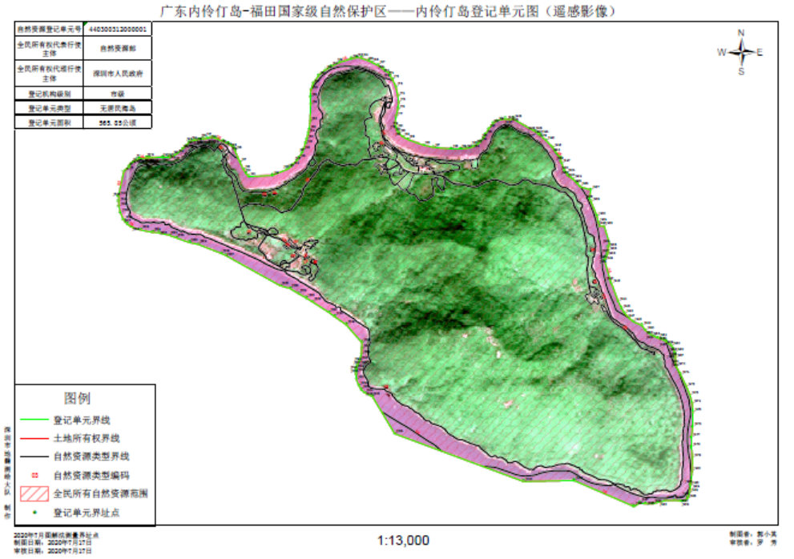

内伶仃岛自然资源登记单元坐标表
界址点号 | X坐标 | Y坐标
J1 | 2480251.24 | 477526.44
J2 | 2480280.46 | 477557.2
J3 | 2480283.28 | 477558.45
J4 | 2480301.82 | 477570.98
J5 | 2480317.49 | 477586.5
J6 | 2480328.12 | 477604.49
J7 | 2480337.13 | 477623.64
J8 | 2480345.22 | 477674.49
J9 | 2480345.97 | 477691.46
J10 | 2480351.26 | 477784.06
J11 | 2480351.82 | 477822.91
J12 | 2480353.53 | 477837.13
J13 | 2480363.15 | 477862.72
J14 | 2480375.37 | 477880.97
J15 | 2480407.3 | 477917.59
J16 | 2480432.77 | 477942.06
J17 | 2480450.96 | 477960.92
J18 | 2480461.5 | 477978.82
J19 | 2480468.4 | 477999.78
J20 | 2480474.44 | 478027.39
J21 | 2480476.89 | 478046.63
J22 | 2480480.22 | 478050.61
J23 | 2480478.23 | 478057.13
J24 | 2480478.4 | 478058.48
J25 | 2480482.38 | 478080.98
J26 | 2480488.55 | 478103.37
J27 | 2480490.05 | 478113.43
J28 | 2480489.14 | 478124.86
J29 | 2480486.44 | 478132.72
J30 | 2480477.58 | 478154.28
J31 | 2480464.75 | 478189.07
J32 | 2480449.8 | 478222.01
J33 | 2480438.31 | 478244.44
J34 | 2480431.48 | 478252.75
J35 | 2480419.97 | 478262.56
J36 | 2480402.75 | 478272.23
J37 | 2480327.08 | 478306.02
J38 | 2480279.21 | 478330.44
J39 | 2480252.31 | 478347.31
J40 | 2480229.95 | 478366.91
J41 | 2480241.29 | 478525.75
J42 | 2480282.26 | 478622.95
J43 | 2480291.22 | 478635.58
J44 | 2480310.37 | 478657.71
J45 | 2480342.68 | 478688.83
J46 | 2480360.86 | 478701.79
J47 | 2480398.17 | 478723.49
J48 | 2480414.64 | 478730.2
J49 | 2480458.03 | 478744.71
J50 | 2480488.31 | 478753.26
J51 | 2480526.29 | 478762.36
J52 | 2480556.09 | 478768.3
J53 | 2480612.31 | 478774.26
J54 | 2480723.79 | 478776.26
J55 | 2480774.6 | 478773.08
J56 | 2480820.11 | 478775.72
J57 | 2480862.44 | 478789.48
J58 | 2480916.94 | 478824.94
J59 | 2480955.58 | 478869.39
J60 | 2480980.17 | 478908.08
J61 | 2481009.94 | 478967.22
J62 | 2481036.72 | 479044
J63 | 2481043.95 | 479081.58
J64 | 2481040.96 | 479111.73
J65 | 2481022.34 | 479164.48
J66 | 2481013.88 | 479182.9
J67 | 2480993.78 | 479226.29
J68 | 2480966.65 | 479264.74
J69 | 2480956.17 | 479276.07
J70 | 2480945.58 | 479298.85
J71 | 2480925.75 | 479306.72
J72 | 2480905.41 | 479323.13
J73 | 2480850.8 | 479347.75
J74 | 2480791 | 479363.11
J75 | 2480745.55 | 479368.17
J76 | 2480703.88 | 479364.2
J77 | 2480651.31 | 479351.8
J78 | 2480606.23 | 479347.68
J79 | 2480589.03 | 479349.36
J80 | 2480572.69 | 479354.39
J81 | 2480559.74 | 479360.11
J82 | 2480547.95 | 479366.89
J83 | 2480538.73 | 479373.89
J84 | 2480516.21 | 479400.26
J85 | 2480498.01 | 479434.46
J86 | 2480463.09 | 479538.7
J87 | 2480449.33 | 479606.97
J88 | 2480439.78 | 479727.63
J89 | 2480441.21 | 479791.13
J90 | 2480444.57 | 479826.57
J91 | 2480455.08 | 479869.38
J92 | 2480462.61 | 479885.46
J93 | 2480474.18 | 479903.43
J94 | 2480491.04 | 479922.27
J95 | 2480519.84 | 479945.18
J96 | 2480537.66 | 479956.19
J97 | 2480578.67 | 479977.7
J98 | 2480617.03 | 480007.13
J99 | 2480634.56 | 480032.6
J100 | 2480643.89 | 480061.6
J101 | 2480646.51 | 480085.71
J102 | 2480647.14 | 480091.54
J103 | 2480644.71 | 480120.35
J104 | 2480643.48 | 480124.96
J105 | 2480648.92 | 480142.03
J106 | 2480571.5 | 480282.18
J107 | 2480568.22 | 480288.62
J108 | 2480566.85 | 480290.62
J109 | 2480555.79 | 480310.64
J110 | 2480547.97 | 480318.1
J111 | 2480542.87 | 480325.53
J112 | 2480506.51 | 480366.54
J113 | 2480460.27 | 480412.44
J114 | 2480430.27 | 480430.35
J115 | 2480392.42 | 480466.45
J116 | 2480368.91 | 480466.07
J117 | 2480355.02 | 480473.51
J118 | 2480317.6 | 480488.49
J119 | 2480310.9 | 480490.54
J120 | 2480304.18 | 480493.45
J121 | 2480287.21 | 480506.55
J122 | 2480275.59 | 480517.21
J123 | 2480261.54 | 480536.05
J124 | 2480249.13 | 480552.67
J125 | 2480220.56 | 480582.3
J126 | 2480201.3 | 480598.66
J127 | 2480178.9 | 480672.12
J128 | 2480117.77 | 480662.72
J129 | 2480099.38 | 480675.96
J130 | 2480004.13 | 480717.24
J131 | 2479961.79 | 480726.29
J132 | 2479936.98 | 480737.26
J133 | 2479936.49 | 480767.27
J134 | 2479816.12 | 480805.33
J135 | 2479796.24 | 480794.81
J136 | 2479771.13 | 480795.38
J137 | 2479755.56 | 480793.71
J138 | 2479738.38 | 480787.75
J139 | 2479726.72 | 480781.5
J140 | 2479713.33 | 480775.94
J141 | 2479703.72 | 480773.86
J142 | 2479567.86 | 480814.95
J143 | 2479547.46 | 480824.66
J144 | 2479434.74 | 480868.58
J145 | 2479384.06 | 480894.11
J146 | 2479354.37 | 480913.27
J147 | 2479316.54 | 480950.11
J148 | 2479297.71 | 480972.58
J149 | 2479271.94 | 481033.65
J150 | 2479238.09 | 481057.06
J151 | 2479216.73 | 481084.49
J152 | 2479205.45 | 481102.52
J153 | 2479196.82 | 481122.37
J154 | 2479190.26 | 481142.69
J155 | 2479184.08 | 481160.7
J156 | 2479179.46 | 481182.25
J157 | 2479167.46 | 481196.44
J158 | 2479165.85 | 481199.31
J159 | 2479147.17 | 481224.79
J160 | 2479138.61 | 481233.22
J161 | 2479116.89 | 481247.75
J162 | 2479100.86 | 481255.58
J163 | 2479095.07 | 481257.42
J164 | 2479082.52 | 481259.85
J165 | 2479077.7 | 481260.39
J166 | 2479068.6 | 481260.81
J167 | 2479055.39 | 481260.45
J168 | 2479034.19 | 481260.28
J169 | 2479019.08 | 481262.37
J170 | 2478997.27 | 481269.97
J171 | 2478946.32 | 481298.27
J172 | 2478866.92 | 481338.31
J173 | 2478807.11 | 481364.53
J174 | 2478752.84 | 481379.63
J175 | 2478698.38 | 481385.45
J176 | 2478593.36 | 481385.06
J177 | 2478520.59 | 481378.68
J178 | 2478458.04 | 481379.68
J179 | 2478385.93 | 481387.69
J180 | 2478296.84 | 481386.69
J181 | 2478217.71 | 481380.44
J182 | 2478207.92 | 481378.42
J183 | 2478201.22 | 481377.44
J184 | 2478153.94 | 481372.12
J185 | 2478129.86 | 481366.89
J186 | 2478113.94 | 481359.65
J187 | 2478098.6 | 481344.3
J188 | 2478095.5 | 481333.47
J189 | 2478096.06 | 481310.01
J190 | 2478097.01 | 481304.62
J191 | 2478099.66 | 481273.39
J192 | 2478096.48 | 481211.49
J193 | 2478084.84 | 481161.74
J194 | 2478073.72 | 481127.87
J195 | 2478072.13 | 481078.13
J196 | 2478075.84 | 481043.74
J197 | 2478078.22 | 481038.44
J198 | 2478053.18 | 480999.44
J199 | 2478221.28 | 480593.51
J200 | 2478208.48 | 480253.68
J201 | 2478515.62 | 479380.31
J202 | 2478761.92 | 479226.76
J203 | 2478766.4 | 479218.11
J204 | 2478789.82 | 479171.28
J205 | 2478809.54 | 479149.02
J206 | 2478834.67 | 479133.44
J207 | 2478876.62 | 479115.89
J208 | 2478911.8 | 479112.06
J209 | 2478929.39 | 479112.28
J210 | 2478942.83 | 479113.98
J211 | 2478951.05 | 479108.85
J212 | 2478968.41 | 479120.03
J213 | 2478993.58 | 479129.63
J214 | 2478998.71 | 479132.39
J215 | 2479003.77 | 479134.97
J216 | 2479047.92 | 479146.67
J217 | 2479084.44 | 479147.73
J218 | 2479126.03 | 479149.12
J219 | 2479244.69 | 479040.62
J220 | 2479297.69 | 478961.46
J221 | 2479326.07 | 478921.7
J222 | 2479394.38 | 478810.76
J223 | 2479420.73 | 478767.99
J224 | 2479449.04 | 478714.34
J225 | 2479481.56 | 478659.09
J226 | 2479500.29 | 478590.4
J227 | 2479697.24 | 478221.44
J228 | 2479710.97 | 478189.93
J229 | 2479768.65 | 478034.89
J230 | 2479780.29 | 477974.04
J231 | 2479810.45 | 477884.08
J232 | 2479826.86 | 477836.99
J233 | 2479842.2 | 477766.07
J234 | 2479844.32 | 477725.33
J235 | 2479858.61 | 477644.37
J236 | 2479880.3 | 477579.81
J237 | 2479898.6 | 477552.82
J238 | 2479924.68 | 477530.52
J239 | 2479970.69 | 477509.31
J240 | 2480011.32 | 477497.98
J241 | 2480048.31 | 477496.2
J242 | 2480076.03 | 477497.26
J243 | 2480082.66 | 477493.31

（备注：2000国家大地坐标系，高斯-克吕格投影，统一3°带，114°中央子午线）

